Coleman Electronics Challenge – To Solve



Company Background
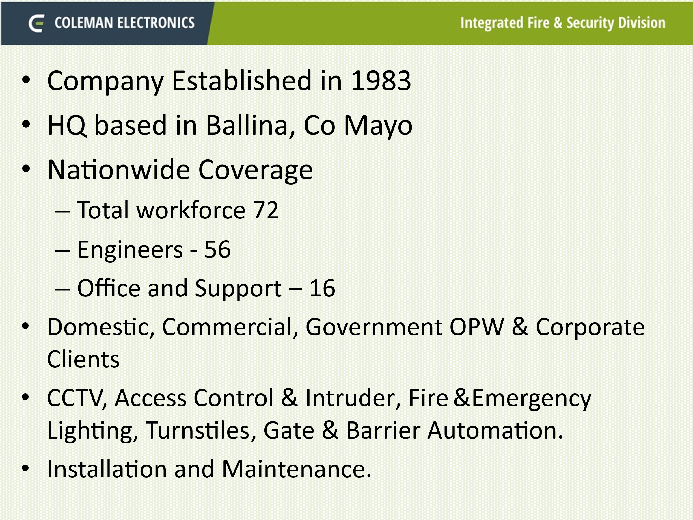

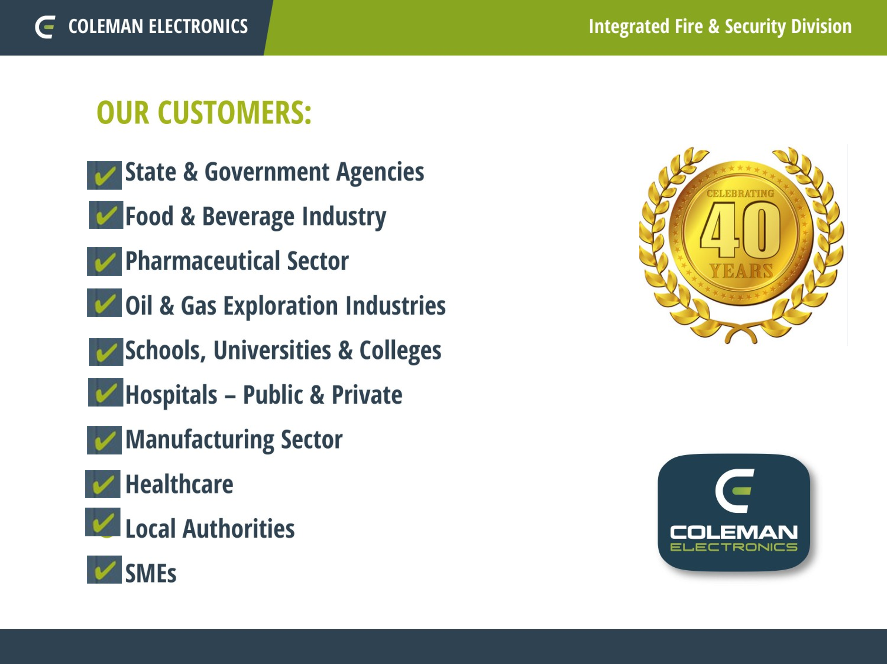
Current System and Challenge
The existing job planning and tracking tool utilized by our Engineers is called AFS (Advanced Field Solutions) and is operational for the past 7 years and operates primarily as a phone-based app.
Whilst this system works very well and has a very good usage activity from our Engineers, it is very much a stand-alone system and not connected to any other business systems within the overall office environment.
Most of the other business systems are Microsoft Access based.
Currently each team/department is working in a silo approach resulting in duplication and missing of tasks.
Quoting and Pricing Tool Integration
Currently all quotes are generated within an existing Access based system where it pulls in the component’s costs which are updated regularly to reflect changes in supply chain costs and generates a final cost including parts and labour.
Each quote is given a unique number and there is good search functionality within the system to search via customer, location, job description etc.
Once the quote is completed within Access it is then converted to a pdf in company headed paper, saved to a company drive and emailed manually to the customer.
Once the customer receives the quote and forwards on a PO number – that job then gets logged on the AFS tool and is given a unique AFS job number.
The job is then planned through AFS and assigned to an Engineer to complete.
Where parts or components are required for the same job – an email is sent directly to the Inventory Stores Team where they generate an order through an Access based system and issue the PO to the vendor.
There is no direct link or connection between the Access based system and the AFS system.

Invoicing and Payment Process
Invoicing of Debtors & Payment of Creditors
Once a job is closed in AFS (this happens once all works are completed as per the scope and PO) an invoice will be prepared manually through an Access system and issued to the customer for payment and tracked for payment through the access system.
The AFS system must be checked manually to confirm the status of the job there. (Open/closed)
Once parts that were ordered and have been delivered and received into stores a creditor invoice will be received and tracked through the Access system and payment will be made to that vendor.
Again, there is no direct link between the AFS system and the accounts Access system, both are working independently to each other.
Inventory Stock Control
Management of inventory and non-inventory stock in the stores is managed through an Access based system.
Payroll System
Currently Payroll is managed through a stand-alone PC based software-based system.

Key Functional Requirements
The proposed software solution must address the challenges above by offering:
- A system capable of integrating directly with the existing AFS System.
- Provide an integrated module for quotation management including a workflow for the submitting of quote requests, generation, approval, issuing of quotes and ongoing tracking of quotes.
- Capable of linking the quote to the assigned job in AFS.
- Provide an integrated module for Invoicing of Debtors & Payment of Creditors that is linked and tied into the quote module & the AFS system.
- Cost tracking and reporting, capable of tracking the actual labour consumed which will be tracked through the AFS system.
- Cost tracking and reporting: capable of reporting on the material consumed against the job.
- Cost tracking and reporting: based on the 2 requirements above the proposed system must be capable of review each job quote and compare against actual labour and material consumed.
- Provide an integrated module for inventory management linked to the AFS system, the creditors and debtor system, with features supporting PO generation, good receipt, parts issuing, minimum reorder levels etc & inventory control and counts.
- Removal of duplication and overlap from the existing internal systems.
- Provie greater communication and collaboration between different departments.

Desired Features
- User roles and permissions: custom access levels for different teams and individuals.
- Centralized customer database
- Accurate and up-to-date records
- Data import/export capability (CSV, Excel, API)
- Workflow triggers and reminders.
- Automated Task assignment.
- Automated notifications and reminders.
- Real Time Dashboards.
- Customisable Reports.
- Custom reporting and predictive analytics to ensure intelligent use of the available inputted data within the system.
- Easily modified for changes due to business needs.
- Regular software updates
- Technical support
- Data backup & recovery

Integration Requirements
- Integrate into the existing AFS system
- Integrate into the existing various Access based systems in uploading historic and master data for the initial cut over activity. Not required to integrate on an ongoing basis.
- Integrate into existing employee profiles for payroll purposes.

